**MINI-PROJECT – 1**

**(2020-2021)**

**Website for Mental Health Issues**

**MID-TERM REPORT**



**Institute of Engineering & Technology**

**Submitted by-**

Bhakti Sharma (University Roll No. – 181500190)

Deeksha Mishra (University Roll No. – 181500201)

Pranshi Agarwal (University Roll No. – 181500482)

**Supervised By:-**

**Mr. Anand Kumar Gupta**

**Mrs. Ruchi Gupta**

Technical Trainer

**Department of Computer Engineering &Applications**

**CONTENTS**

**Abstract 3**

**1. Introduction 4**

1.1 General Introduction to the Topic **4-5**

1.2 Area of Computer Science **6**

1.3 Hardware and Software Requirements **7**

**2. Problem Definition 8**

**3. Objectives 9**

**4. Implementation Details 10**

**5. Progress till Date and the Remaining work 10**

**6. Some Screenshots 11-12**

**7. References 13**

**Abstract**

Mental Health, as we all know, is often neglected before. The number of increased cases in suicides has taken everybody’s attention to the issues regarding mental health. People now are slowly getting aware of the fact that mental health is as necessary as physical health. So, we are here planning to make a website for mental health issues through which we can spread awareness regarding mental health and all those things which come under the same.

Our goal is to make an efficient and responsive website where the user is likely to know about what are those mental issues one should know. What are the preventions and cure of these issues. We would also be providing a space to vent-out the emotions, one is going through. So, in all we are making a little effort to provide help to those suffering from the different types of issues that come under mental health.

**Introduction**

* 1. **General Introduction to the Topic**

Mental health includes our emotional, psychological, and social well-being. It affects how we think, feel, and act. It also helps determine how we handle stress, relate to others, and make choices. Mental health is important at every stage of life, from childhood and adolescence through adulthood.

Over the course of your life, if you experience mental health problems, your thinking, mood, and behaviour could be affected. Many factors contribute to mental health problems, including:

* Biological factors, such as genes or brain chemistry
* Life experiences, such as trauma or abuse
* Family history of mental health problems

Mental health problems are common but [help is available](https://www.mentalhealth.gov/get-help). People with mental health problems can get better and many recover completely.

## Early Warning Signs

Not sure if you or someone you know is living with mental health problems? Experiencing one or more of the following feelings or behaviours can be an early warning sign of a problem:

* Eating or sleeping too much or too little
* Pulling away from people and usual activities
* Having low or no energy
* Feeling numb or like nothing matters
* Having unexplained aches and pains
* Feeling helpless or hopeless
* Smoking, drinking, or using drugs more than usual
* Feeling unusually confused, forgetful, on edge, angry, upset, worried, or scared
* Yelling or fighting with family and friends
* Experiencing severe mood swings that cause problems in relationships
* Having persistent thoughts and memories you can't get out of your head
* Hearing voices or believing things that are not true
* Thinking of harming yourself or others
* Inability to perform daily tasks like taking care of your kids or getting to work or school

## Mental Health and Wellness

Positive mental health allows people to:

* Realize their full potential
* Cope with the stresses of life
* Work productively
* Make meaningful contributions to their communities

Ways to maintain positive mental health include:

* Getting professional help if you need it
* Connecting with others
* Staying positive
* Getting physically active
* Helping others
* Getting enough sleep
* Developing coping skills
  1. **Area of Computer Science**

Accessing mental health websites help people understand and recognise mental health difficulties, and to start making the steps towards recovery.

* **Convenience:** Treatment can take place anytime and anywhere (e.g., at home in the middle of the night or on a bus on the way to work) and may be ideal for those who have trouble with in-person appointments.
* **Anonymity:** Clients can seek treatment options without involving other people.
* **An introduction to care**: Technology may be a good first step for those who have avoided mental health care in the past.
* **Lower cost**: Some apps are free or cost less than traditional care.
* **Service to more people**: Technology can help mental health providers offer treatment to people in remote areas or to many people in times of sudden need
* **Interest**: Some technologies might be more appealing than traditional treatment methods, which may encourage clients to continue therapy.
* **24-hour service**: Technology can provide round-the-clock monitoring or intervention support.
* **Consistency**: Technology can offer the same treatment program to all users.
* **Support**: Technology can complement traditional therapy by extending an in-person session, reinforcing new skills, and providing support and monitoring.
  1. **Hardware Requirements**

. Processor: Intel dual core or above

. Processor Speed: 1.0GHZ or above

. RAM: 1GB RAM or above

. Hard Disk: 20 GB hard disk or above

* 1. **Software Requirements**

. Operating System: Windows 8.1 or above

. Front End: HTML, CSS, Bootstrap, JS

. Back End: Node JS

. Text Editor: Visual Studio Code

. Web Browser: Google Chrome

**Problem Definition**

Here we are planning to make a website for mental health issues. So, our problem statement lies on how our website would be able to provide information to user about various mental health issues. How our website would be interactive to the user? How will we be able to solve various problems regarding mental health issues? How we will be able to provide counsellors or listeners to the user? And how will the counsellors interact with the users? And many more issues which we will encounter with time. But our main problem is to make our websites useful for the users as well as the listeners or counsellors.

**Objective**

Our objective is to make our website interactive to the users as well as the counsellors who are counselling them. Our main focus is to make the user aware about the various mental health issues and also to connect them to a good counsellor. We want to make our website, a place where people can vent-out their problems. We will list different articles on topics which come under mental health and the problems which have been encountered before regarding the same. We will also like to bring real-life stories of people who overcame or are trying to overcome the problems they are facing. We would also like to make the user aware about “Suicide prevention”. And also we would like to solve various problems which we will encounter with time

**Implementation Detail**

**Part1:** To build a home page using HTML and CSS

In this section we include the details like contacts ,FAQs ,Reviews and login and signup page.

We also provide the counsellor images and details to choose the best one someone need for himself. Also providing the social media account like facebook ,Instagram and twitter with some big newspaper articles like The New York Times ,

SELF etc.

**Part2:** To build other supporting web pages and apply

Javascript coding in all the web pages with all effects to improve the visual and features of the website.

**Part3:** To work on backend part using Nodejs to create a event-driven server database for website to store the data .

**Progress**

Part1 is completed .

**Screenshot**



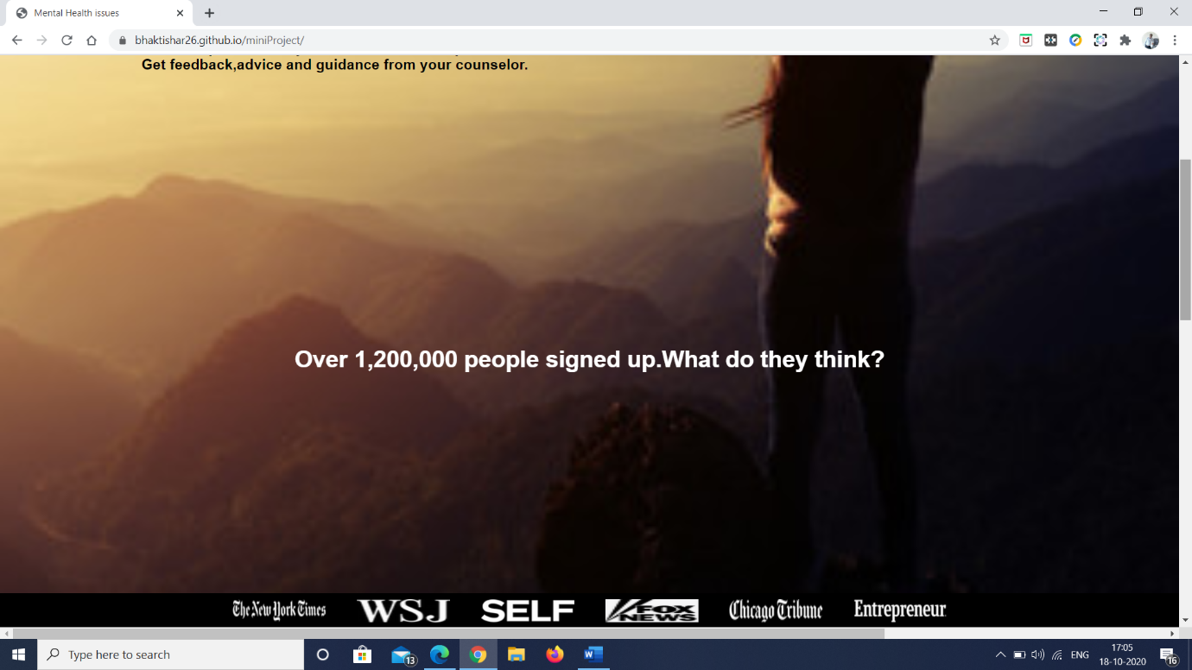

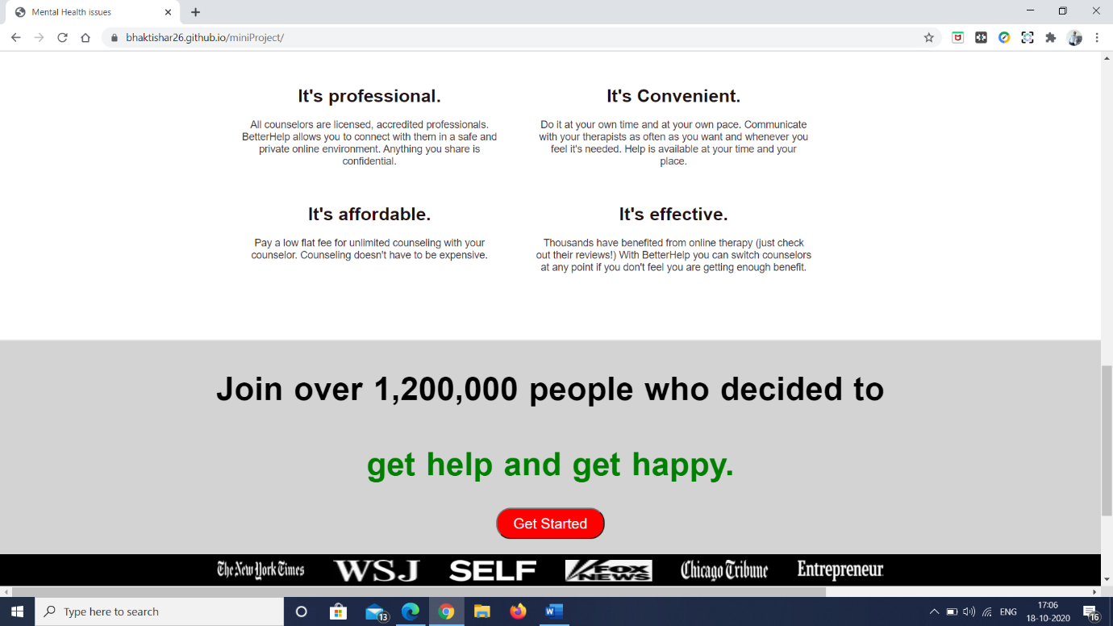

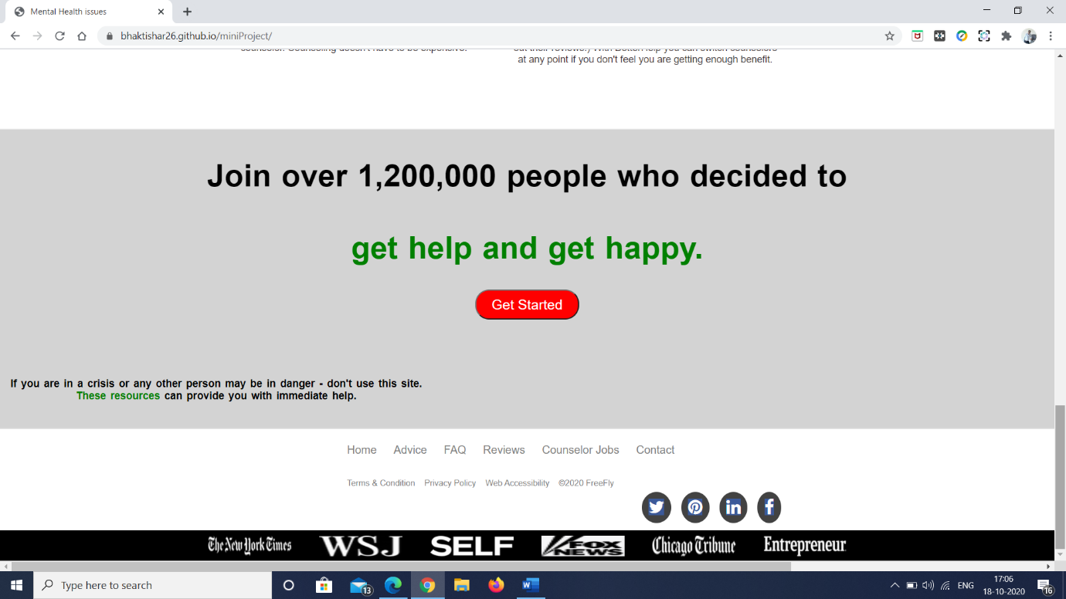

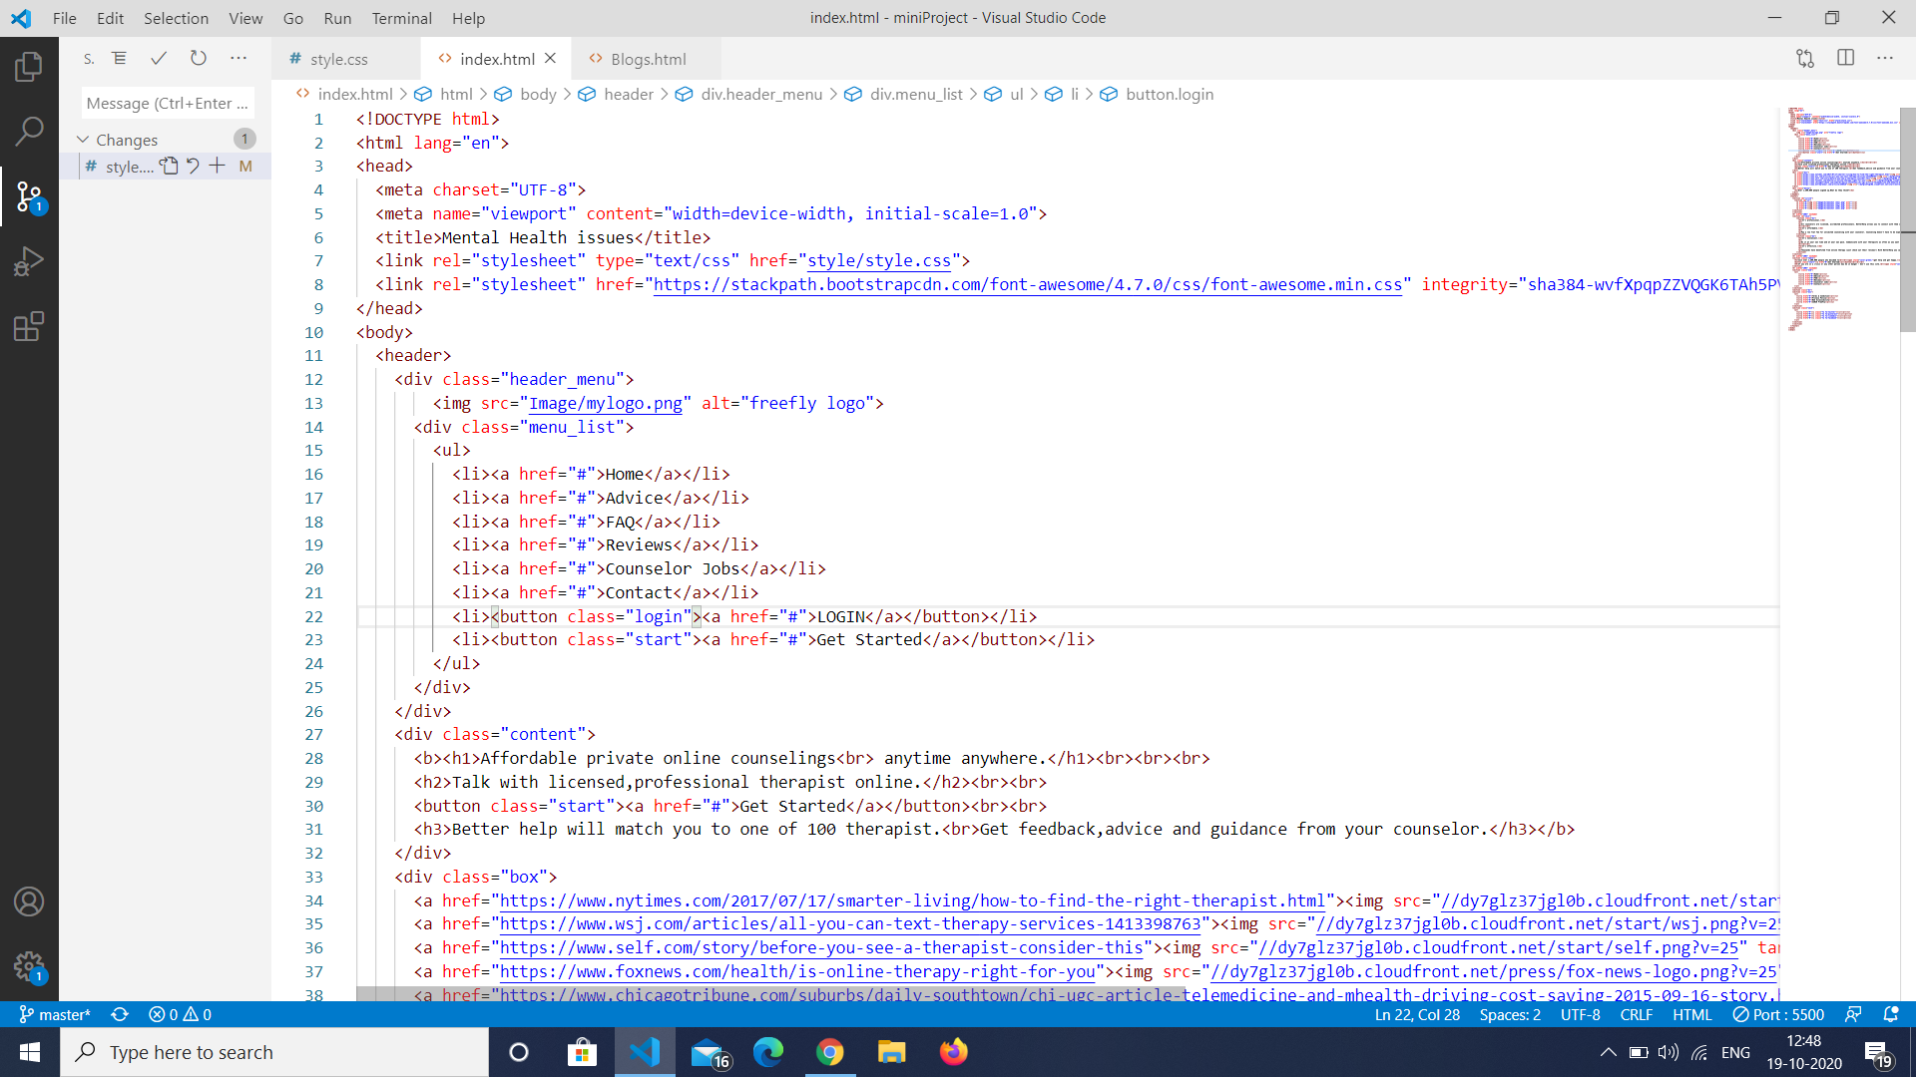

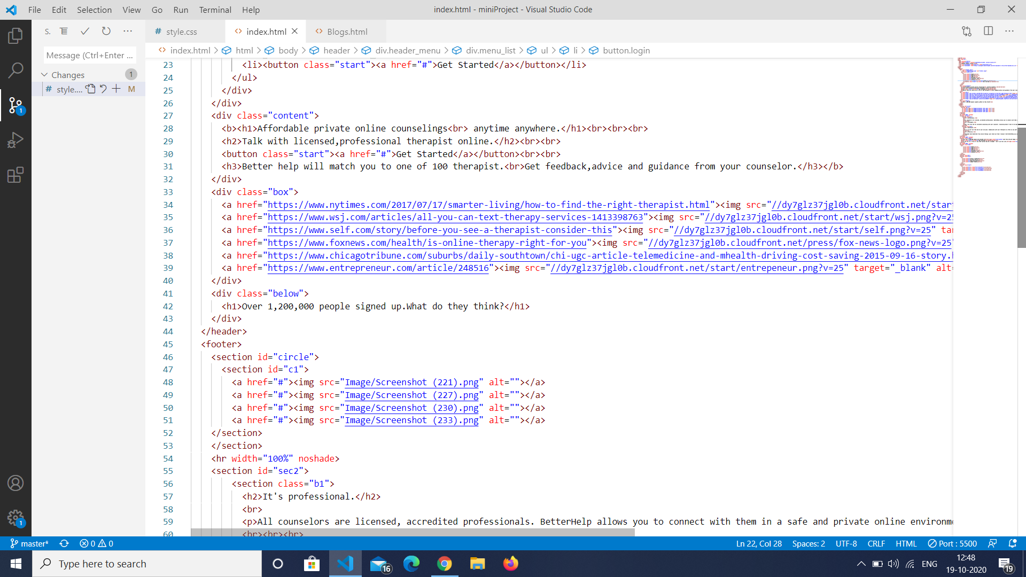

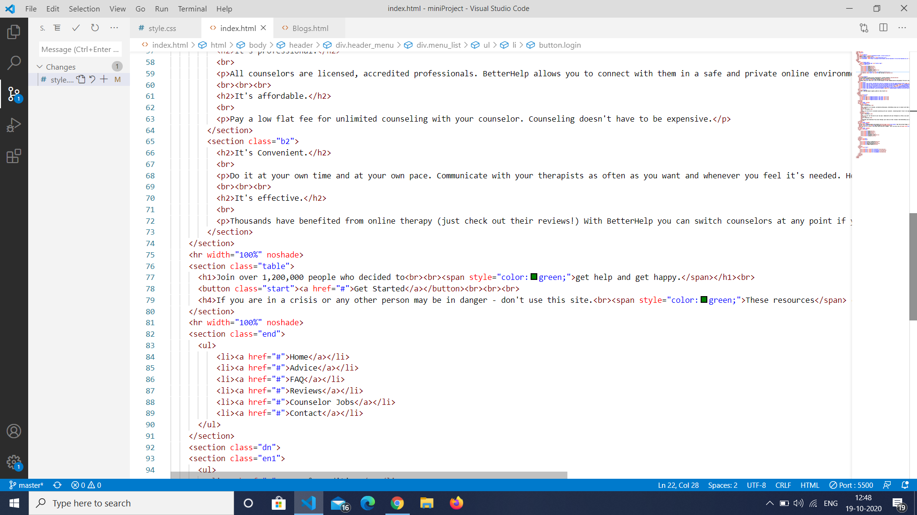

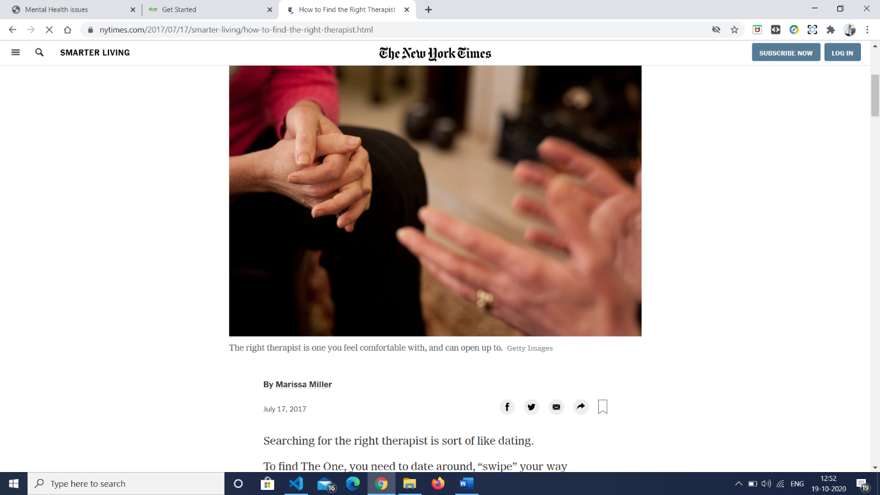

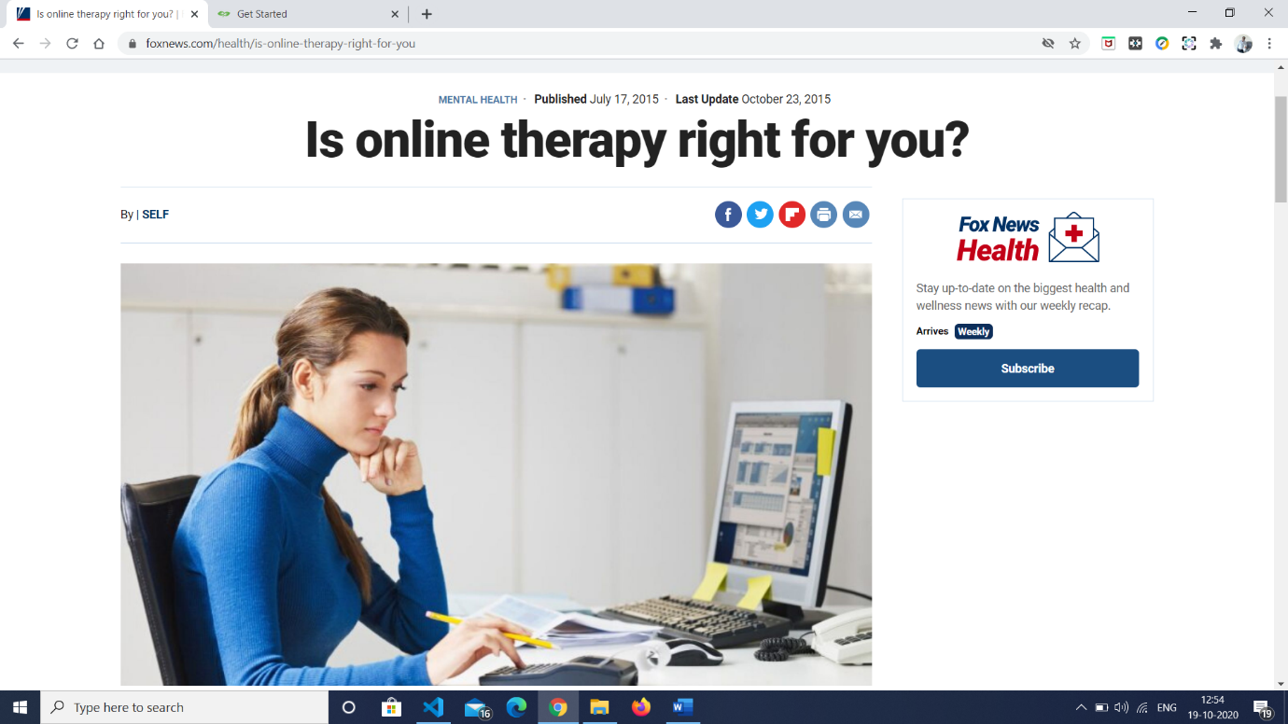

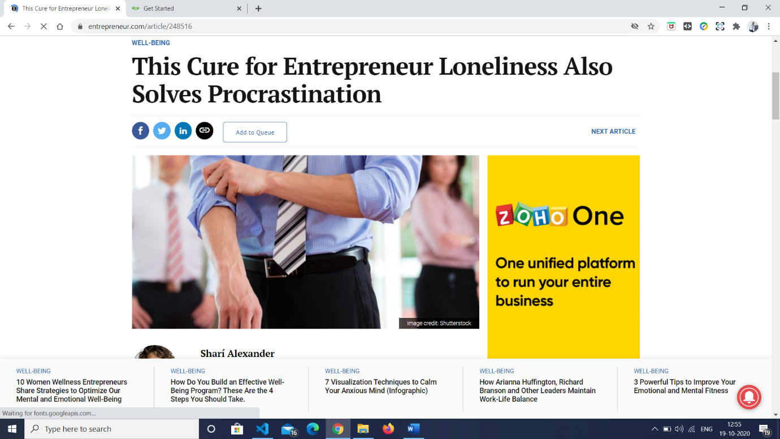

**References**

* [www.wikipedia.org](http://www.wikipedia.org)
* [www.github.com](http://www.github.com)
* [www.pinterest.com](http://www.pinterest.com)
* [www.w3schools.com](http://www.w3schools.com)
* [www.coursera.com](http://www.coursera.com)
* [www.stackoverflow.com](http://www.stackoverflow.com)